CU

CURRICULUM VITAE
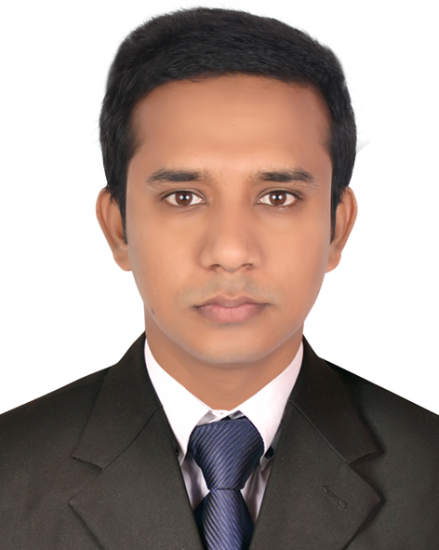
Mohammed Mahsin
Flat #6B, Bhuyian Villa, House #21, Road #01
Mohammadia Housing Ltd. Mohammadpur -1207
Cell: +88-01727796695
E-mail: mdmahsin825@gmail.com

Career objective

- To build up my career in the field of some challenging post in any organization
Where there is immense scope to work and prove ones expertise and maneuver
Positive contribution in the organization by sincerely accomplishing the duties
And responsibilities assigned to me.

Academic Qualification

Master of Business Administration (MBA) :

Institute : Dhaka College, Dhaka.
Affiliated : University of Dhaka.
Subject : Management.
Result : Appeared

Bachelor of Business Administration (BBA) :

Institute : Noakhali Govt. College, Noakhali.
Affiliated : National University, Bangladesh.
Subject : Management.
Passing Year : 2013
Result : G.P.A-3.10 (Out of 4.00)

Higher Secondary School Certificate (H.S.C) :

Institute : Hatia Dwip Govt. College.
Group : Business Studies
Board : Comilla
Passing Year : 2009
Result : G.P.A-3.30 (Out of 5.00)

Secondary School Certificate(S.S.C) :

Institute : Burirchar Shahed Ali Ahammad Memorial High School.
Group : Business Studies
Board : Comilla
Passing Year : 2007
Result : G.P.A-3.31(Out of 5.00)

Training Course

I have completed 6(six) months COMPUTER OPERATION course from
Noakhali Technical Training Centre (Under BMET), Noakhali.

Working Experience

I have an experience as a Conference Associate in International Conference On
Teaching and Learning (ICTL) Organized By Center for Pedagogy at Independent University, Bangladesh (IUB), Dhaka.

Other Personal details

Father’s Name : Mizanur Rahman
Mother’s Name : Firoza Akter
Date of Birth : 29-12-1991
Nationality : Bangladeshi (By Birth)
Religion : Islam
Sex : Male
Marital Status : Single
Blood Group : A+ve
Height : 5 feet 10 inch
Weight : 80kg
National ID No : 19917513615000217
Permanent Address : C/O: Soraf Uddin Haji Bari, Village: Kalirchar,
Post: Burirchar-3890, PS: Hatia, Dist: Noakhali.

LANGUAGE ABILITY

- Bengali(Native)
- Good command in writing & spoken English.

Computer Skills

- MS office Programs (Word, PowerPoint)
- Capable to grab facilities of Internet

Interests

- Work for Humanity.
- Travelling.
- Photography.

Self Assessment

- Excellent negotiation, interpersonal communication skills.
- Effective presentation skills.
- Being able to interest with people at all levels & work as a team player.
- Like to take challenges & ready to work under pressure.
- Self-motivated & optimistic by nature.

References

- M K Sobir Ahammad
Professor,Department of Management
Noakhali Govt. College. Noakhali.
Cell: 01686105722

Declaration

I do declare that all the above information is true and correct to the best of my knowledge.

---------------------
Date : ---/---/-------- Signature

